Join Now Instructions: UMPSA
- Fill out your personal and mailing information.
- For membership category, select: Certified
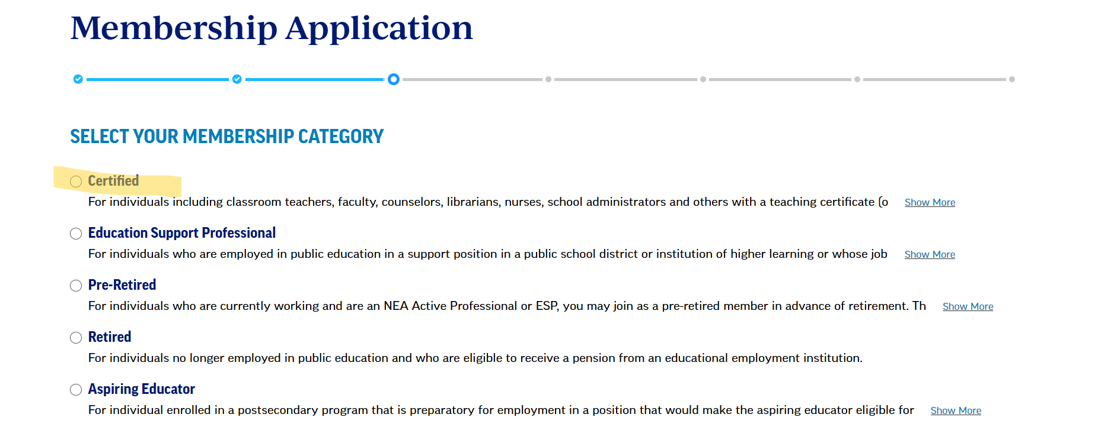
- For employer, select: University of Maine System.
For work location, select: the campus you work for in the system.
For primary position, select: Academic Administrator
For hours worked, select the following based on your current salary:
Full time: you make $47,970 or more
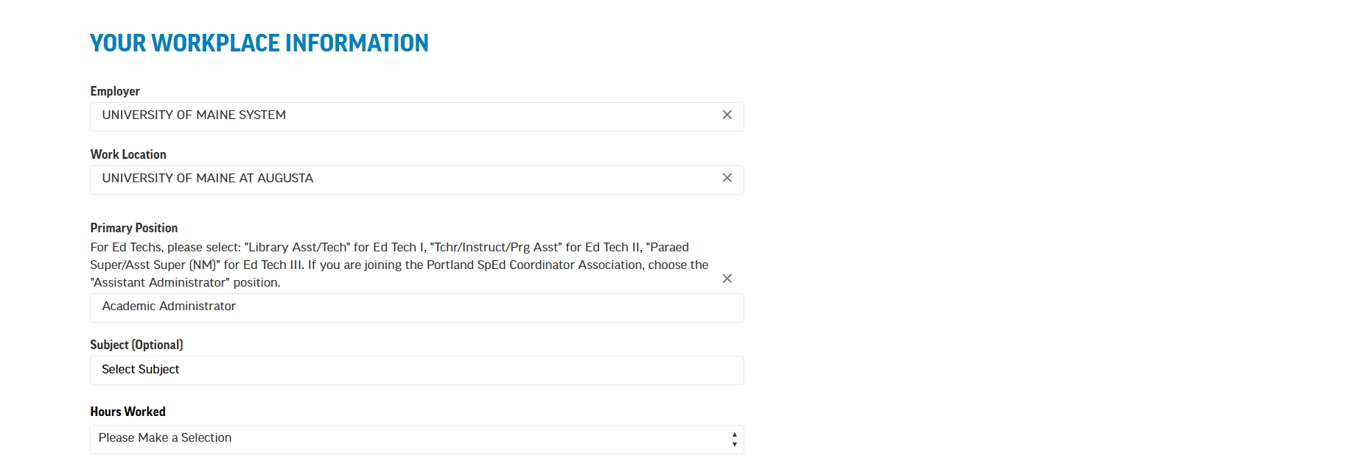
Part time: you make less than $47,970
- You should then see the following and will check all of the boxes beneath.
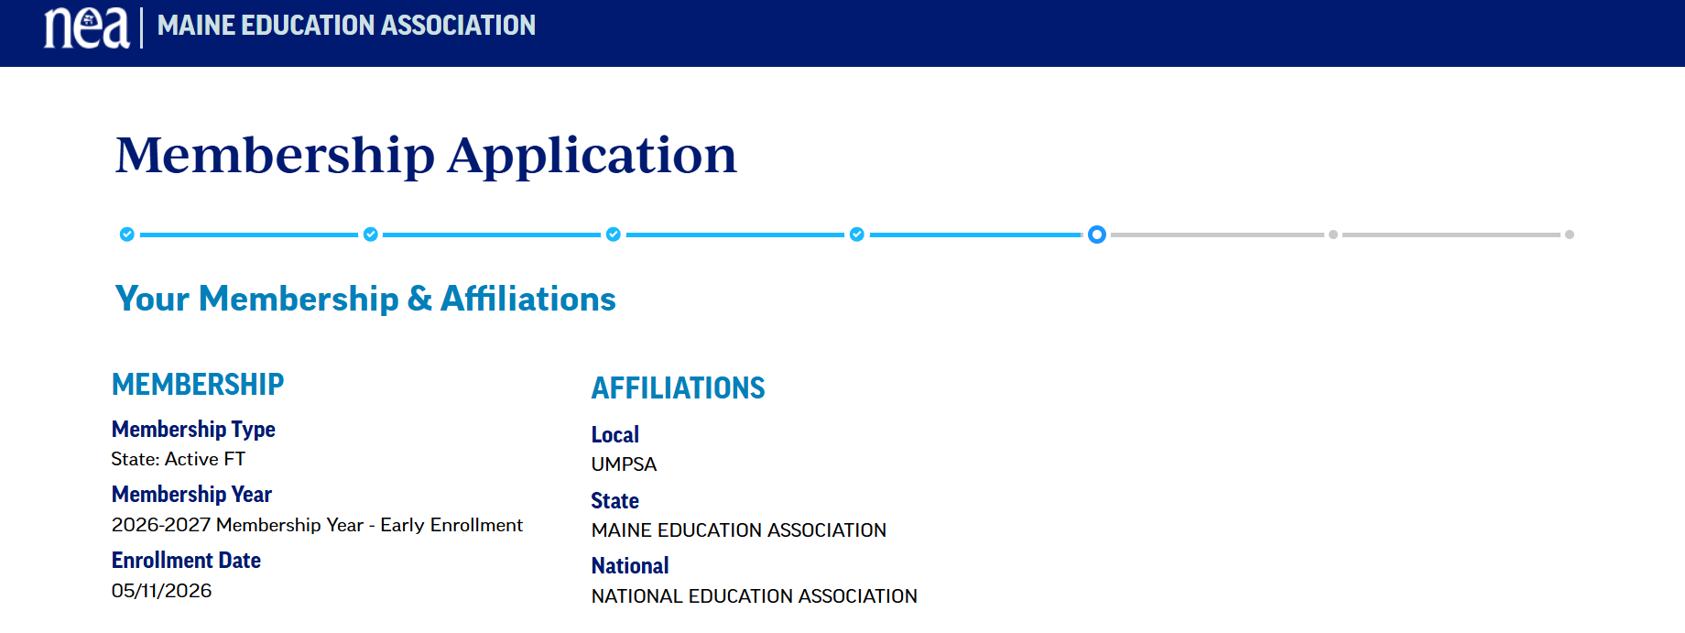
- From there, you will select your payment type and finalize your application to become a member. You should get an email with more information shortly after your application is submitted. Welcome to UMPSA and the MEA!

